Final Year Design Project System Design Specification
Mom N Baby SmartCare
Final Year Design Project SDS
Project ID: 22-KS-BSIT-05
by
Syeda Nawal Naqvi 089318 (2022-ks-357)
Sibgha Arfan 089315 (2022-ks-354)
(Morning)
Project Advisor:
Sir Hasan Raza
Govt. Graduate College, Civil Lines, Sheikhupura
University of the Punjab Lahore, Pakistan
(2025)
Mom N Baby SmartCare
Executive Summary
The Mom N Baby SmartCare App is designed to provide a simple and reliable digital solution that helps mothers and caregivers manage maternal and baby health information efficiently. The application allows users to store and track important records such as baby growth details, vaccination schedules, reminders, and other essential health information in one place. This reduces the risk of losing important records and makes it easier for parents to monitor the health and development of their child. This Software Design Specification (SDS) document describes the overall design of the system, including the architecture, user interface, and database structure of the application. The app is developed using Android Studio with Firebase Database, which ensures secure data storage, user authentication, and smooth performance, making it a convenient and user-friendly platform for supporting better care for both mother and baby.
Table of Contents
3.1 Requirements Analysis: 1
3.1.1 User classes and characteristics: 1
3.1.2 Requirement Identifying Technique: 1
3.2 Functional Requirements: 2
3.2.1 Functional Requirements X: 4
3.3 Non-Functional Requirements: 11
3.4 External Interface Requirements: 12
3.4.1 User Interface Requirements: 13
3.4.2 Software Interfaces: 13
3.4.3 Hardware Interfaces: 13
3.4.4 Communication Interfaces: 14
3.5 Use Case Analysis: 14
Use Case #1: User Registration and Login 14
Use Case #2: Forgot Password 15
Use Case #3: Manage Mom and Baby Profile 16
Use Case #4: Mother Health Tracking 17
Use Case #5: Baby Health Tracking 17
Use Case #6: Reminder Management 18
Use Case #7: Notifications 19
Use Case #8: Settings Management 19
Use Case #9: Logout 20
3.6 Use Case Diagram: 21
3.7 Storyboards: 22
3.8 Summary: 26
References: 27

List of Tables
Table 1 Functional Requirements Specification (User Registration)…………………4
Table 2 Functional Requirements Specification (Email Verification)………………..4
Table 3 Functional Requirements Specification (User Login)………………………..5
Table 4 Functional Requirements Specification (Forgot Password)………………….5
Table 5 Functional Requirements Specification (Manage Mother Profile)…………..6
Table 6 Functional Requirements Specification (Manage Baby Profile)…………….6
Table 7 Functional Requirements Specification (Mother Health Tracker)…………..7
Table 8 Functional Requirements Specification (Baby Health Tracker)…………….7 Table 9 Functional Requirements Specification (Reminder Management)………….8
Table 10 Functional Requirements Specification (Records and Graphs)……………8
Table 11 Functional Requirements Specification (Health Schedule)………………..9
Table 12 Functional Requirements Specification (Notifications)………………...…9
Table 13 Functional Requirements Specification (Settings Management)………….10
Table 14 Functional Requirements Specification (Logout)…………………………10
Table 15 Use Case Description for User Registration and Login…………………...14
Table 16 Use Case Description for Forgot Password……………………………….15 Table 17 Use Case Description for Manage Mom and Baby Profile……………….16
Table 18 Use Case Description for Mother Health Tracking……………………….17
Table 19 Use Case Description for Baby Health Tracking………………………....17
Table 20 Use Case Description for Reminder Management………………………..18
Table 21 Use Case Description for Notifications…………………………………...19 Table 22 Use Case Description for Settings Management………………………….19
Table 23 Use Case Description for Logout…………………………………………20 Table of Figures
Figure 1 Use Case Diagram……………………………………………………………21
Figure 2 Storyboard 1 (App Awareness & Installation)……...………………………..22
Figure 3 Storyboard 2 (Registration & Login)……………….………………………..22
Figure 4 Storyboard 3 (Home Dashboard Access)…………………………………….23
Figure 5 Storyboard 4 (Mom N Baby Creation).………………………...…….…..…..23
Figure 6 Storyboard 5 (Mother Health Tracking)……………………….…………….24
Figure 7 Storyboard 7 (Baby Health Tracking)………………………………………..24
Figure 8 Storyboard 8 (Reminders & Health Schedule)……………………………….25
Figure 9 Storyboard 9 ( Settings & Security Management)………………..………….25
Figure 10 Storyboard 10 (Notifications & Logout)…………………………….………26

4.1 System Design
Mom N Baby SmartCare is a mobile application designed to help mothers manage their own health and their baby’s care through a single platform. The systemallows secure user authentication, mandatory profile setup and access to a home
dashboard. Core features such as health tracking, schedules, reminders, notifications
and records with graphs are interconnected to ensure smooth data flow, timely alerts
and reliable health monitoring.

Product Perspective

The product perspective explains the environment in which the Mom N Baby

SmartCare application will operate and how different components of the system

interact with each other. Perspective

Type

Description

Platform

Mom N Baby SmartCare runs on Android mobile devices and is

designed for mothers to manage their own health and their babies’ health using an online application. Database

The system uses Firebase as a cloud based database. Firebase stores

user accounts, mother and baby profile, health tracking data, reminders, notifications, and medical records. Architecture

The application follows a layered architecture. The UI layer

manages user screens, the business logic layer processes health data

and reminders, and the Firebase data layer handles real-time data

storage and retrieval. Authentication

User authentication is managed using Firebase Authentication with

email verification and secure login. Only verified users can access

system features. Notifications

The system uses Firebase Cloud Messaging (FCM) to send health

reminders and notifications to users in real time. Features

Mothers can create and manage profile, track mother and baby

health data, view records with graphs, set reminders, receive

Mom N Baby SmartCare

Govt. Graduate College, Civil Lines, Sheikhupura 46

notifications and manage application settings. Integration

The application integrates with Firebase services such as

Authentication, Realtime Database/Firestore, and Cloud

Messaging. No local storage or offline mode is supported. Dependencies

The system is fully internet dependent. Continuous network

connectivity is required for login, data access, synchronization, and

notifications. Firebase services are essential for system operation. User

Interaction

The application provides screens for registration, login, home page, health tracking, records, reminders, notifications and settings. All

user actions are performed online through the home page. Table 32 Product perspective

Design Constraints

Design constraints describe the limitations and conditions that influence

system design and development. Constraint Type Description

Time Constraint

The project must be completed within the academic

timeline. Documentation and design are completed

first, followed by development, testing, and

implementation. Cost Constraint

This is a student project with limited budget. Firebase

free tier services and open source development tools

are used to reduce cost. Quality Constraint

The system must be secure, reliable, and easy to use. Firebase security rules and authenticated access

ensure data protection and integrity. Scope Constraint

The application focuses only on mother and baby

health management. Hospital systems, doctor

consultations, and offline features are not included.

Mom N Baby SmartCare

Govt. Graduate College, Civil Lines, Sheikhupura 47

Risk Constraint

Since the application is fully online, poor internet

connectivity may affect system usability. Data

security and service availability risks are minimized

through Firebase-managed services and testing. Resource Constraint

The project is developed by students using limited

resources, basic hardware, and standard development

tools. Benefit Constraint

The system reduces manual record keeping and

provides real time access to health data. Firebase

enables scalability, secure storage, and easier

maintenance. Table 33 Design Constraint3.2 Functional Requirements:
The functional requirements of the Mom N Baby SmartCare system explain what the system will do. The requirements are organized by system features. Each functional requirement is uniquely identified to ensure clarity and consistency.
- Registration:
  - The system shall allow the mother to register using a username, email, and password.
  - The system shall verify the email before completing registration.
  - The system shall require the user to confirm the password to ensure correctness.
  - The system shall display an error message for invalid or already registered email.
- Login:
  - The system shall allow the mother to log in using email and password.
  - The system shall validate credentials and provide an error message for incorrect email or password.
  - The system shall provide a forgot password option if login fails.
- Forgot Password:
  - The system shall allow the mother to reset the password by entering the registered email.
  - The system will send an email verifying the reset request.
  - The system shall allow the mother to set a new password after verification.
- Reminder Management:
  - The system shall allow the mother to add, edit, view and delete reminders.
  - The system shall notify the mother on the basis of scheduled reminders.
- Mom N Baby Profile:
  - The system shall allow the mother to add, edit and view her profile and the baby's profile.
  - The profile shall include mother’s name, age, baby’s name, and baby’s date of birth.
- Records & Graphs:
  - The system shall allow the mother to add, edit, view and delete health records.
  - The system shall track and display record or graphs for glucose level, blood pressure, weight, and digestion info.
- Health Schedule:
  - The system shall allow the mother to view, select and deselect health schedule.
- Settings:
  - The system shall allow the mother to change password, theme and email.
  - Changing password shall require entering old password and confirming the new password.
- Mother Health Tracker:
  - The system shall allow the mother to track her glucose level, blood pressure, weight, and digestion info.
  - The system shall allow adding, updating, viewing and deleting health records.
- Baby Health Tracker:
  - The system shall allow the mother to track the baby's weight, milestones, allergies, and medical records.
  - The system shall allow adding, updating, viewing and deleting baby health records.
- Notifications:
  - The system shall allow the mother to receive notifications about selected health schedules.
  - The mother shall be able to view and mark notifications as read.
- Logout:
  - The system shall allow the mother to log out securely from the app.

3.2.1 Functional Requirements X:
Identifier | FR-1
Title | User Registration
Requirement | The mother shall be able to register an account by providing a username, valid email address, password, and confirmed password. The system shall validate the inputs and send an email verification link upon successful submission.
Source | Project stakeholder
Rationale | Allows secure registeration of users and ensures authenticity of the registered email address.
Business Rule (if required) | One email address can be registered with only one account
Dependencies | None
Priority | High
Table 1: Function Requirements Specification
Identifier | FR-2
Title | Email Verification
Requirement | Upon registration, the system shall send a verification email to the user and shall
 | activate the account only after email verification. | successful
Source | Security requirements
Rationale | Ensures account security and unauthorized access. | prevents
Business Rule (if required) | Verification link must expire defined time period. | after a
Dependencies | FR-1
Priority | High
Table 2: Function Requirements Specification
Identifier | FR-3
Title | User Login
Requirement | The registered mother shall be able to log in using a verified email and password. The system shall authenticate credentials and redirect the user to the home screen upon successful login.
Source | Verified Email
Rationale | Provides secure features. | access | to the application
Business Rule (if required) | Invalid credentials shall result in an error message.
Dependencies | FR-2
Priority | High
Table 3: Function Requirements Specification
Identifier | FR-4
Title | Forgot Password
Requirement | The mother shall be able to reset her password by entering her registered email address. The system shall send a verification link and allow password reset after successful verification.
Source | Registered Email
Rationale | Enables account recovery in case of forgotten credentials.
Business Rule (if required) | Password reset must follow email verification.
Dependencies | FR-2
Priority | High
Table 4: Function Requirements Specification
Identifier | FR-5
Title | Manage Mother Profile
Requirement | The mother shall be able to add, view, edit, and delete her personal profile information including name, age, and basic details.
Source | Mother
Rationale | Allows personalization and accurate health record maintenance.
Dependencies | FR-3
Priority | High
Table 5: Function Requirements Specification
Identifier | FR-6
Title | Manage Baby Profile
Requirement | The mother shall be able to add, view, edit, and delete the baby’s profile information including baby name and date of birth.
Source | Mother
Rationale | Enables accurate identification related health records. | of baby-
Business Rule (if required) | Baby date of birth must be a date. | valid past
Dependencies | FR-3
Priority | High
Table 6: Function Requirements Specification
Identifier | FR-7
Title | Mother Health Tracker
Requirement | The system shall allow the mother to add, view, update, and delete her health data including blood pressure, glucose level, weight, and digestion information.
Source | Mother
Rationale | Helps mothers monitor and maintain their health over time.
Dependencies | FR-3, FR-5
Priority | High
Table 7: Function Requirements Specification
Identifier | FR-8
Title | Baby Health Tracker
Requirement | The system shall allow the mother to add, view, update, and delete baby health data including weight, allergy information, milestone tracking, and medical records.
Source | Mother
Rationale | Supports systematic monitoring of the baby’s growth and health.
Dependencies | FR-3, FR-6
Priority | High
Table 8: Function Requirements Specification
Identifier | FR-9
Title | Reminder Management
Requirement | The mother shall be able to add, edit, view, and delete reminders for medicines, feeding schedules, vaccinations, and other care activities.
Source | Mother
Rationale | Ensures timely completion of important health and care tasks.
Dependencies | FR-3
Priority | High
Table 9: Function Requirements Specification
Identifier | FR-10
Title | Records and Graphs
Requirement | The system shall display health records and generate visual graphs for mother and baby health data to show trends over time.
Source | Mother
Rationale | Helps users understand health progress through visual representation.
Dependencies | FR-7, FR-8
Priority | Medium
Table 10: Function Requirements Specification
Identifier | FR-11
Title | Health Schedule
Requirement | The system shall allow select, and deselect | the mother to view, health schedules
 | related to baby care routines. | and mother health
Source | Mother
Rationale | Assists in organizing health activities. | daily and periodic
Dependencies | FR-3
Priority | Medium
Table 11: Function Requirements Specification
Identifier | FR-12
Title | Notifications
Requirement | The system shall send notifications to the mother for reminders, schedule updates, and important health-related alerts.
Source | Mother
Rationale | Keeps the user informed in real time.
Dependencies | FR-9, FR-11
Priority | High
Table 12: Function Requirements Specification
Identifier | FR-13
Title | Settings Management
Requirement | The mother shall be able to manage application settings including change email, change password, and change theme. Email and password changes shall require email verification.
Source | Use case diagram
Rationale | Allows secure and personalized account management.
Dependencies | FR-2, FR-3
Priority | Medium
Table 13: Function Requirements Specification
Identifier | FR-14
Title | Logout
Requirement | The mother shall be able to securely log out of the application, and the system shall terminate the active session.
Source | Use case diagram
Rationale | Protects user data when the application is not in use.
Dependencies | FR-3
Priority | High
Table 14: Function Requirements Specification

3.3 Non-Functional Requirements:
Mom N Baby SmartCare defines quality requirements that explain how the application will work smoothly, safely, and reliably. These requirements focus on system behavior, performance, and user experience rather than features.
Reliability:
Mom N Baby SmartCare will work reliably during normal use with very few failures. The app shall run for at least 30 days without major failure. If a failure occurs, the system will recover within 5 minutes. Health records, reminders, and profiles will be protected from loss during crashes or unexpected shutdowns. User data shall be backed up automatically once every week, ensuring at least 95% data accuracy and integrity.
Usability:
Mom N Baby SmartCare will be easy to learn and easy to use for mothers with basic mobile phone knowledge. A new user shall complete registration and login within 5 minutes. Frequent tasks, such as adding baby health information, creating reminders, or accessing records, will be completed with 4 or fewer taps. The interface shall be simple, clear, and designed to reduce user mistakes.
Performance:
Mom N Baby SmartCare will perform smoothly during normal operations. Actions such as login, data entry, viewing profiles, and opening health records shall be completed within 3 seconds under normal mobile internet conditions. The app shall run without freezing or noticeable delays during regular use.
Response Time:
Mom N Baby SmartCare will respond quickly to user actions. Opening screens, saving data, updating settings and viewing graphs shall take 2 to 3 seconds. Reminders and notifications will be delivered at the correct time in less than 1 minute.
Security:
Mom N Baby SmartCare will protect user data from unauthorized access. Only registered and logged in users shall access personal and health information. Important actions such as changing passwords or email addresses will require email verification.
User data shall remain private and secure at all times.
Backup:
Mom N Baby SmartCare will automatically back up user data after 24 hours.
Availability:
Mom N Baby SmartCare will be available 99% of the time. Users shall be informed in advance if the system is temporarily unavailable.
Maintainability:
Mom N Baby SmartCare will be built in a modular way so updates, bug fixes and new features shall be added easily without affecting existing functions like health tracking and reminders.
Compatibility:
Mom N Baby SmartCare will work properly on common Android devices and shall support different screen sizes, ensuring a consistent and smooth user experience.

3.4 External Interface Requirements:
Mom N Baby SmartCare defines external interface requirements to ensure that the application communicates correctly with users and any external software, hardware, or communication services. These requirements describe how users interact with the system and how the system connects with external components.

3.4.1 User Interface Requirements:
- Mom N Baby SmartCare provides a simple, clean, and user-friendly interface designed for mothers with basic smartphone knowledge. The application follows standard mobile user interface guidelines to ensure consistency and ease of use.
- Mom N Baby SmartCare uses clear fonts, readable text size, simple icons, and meaningful button labels. The color scheme is soft and comfortable for long usage and images are relevant and easy to understand.
- Mom N Baby SmartCare supports common screen sizes and resolutions, ensuring proper layout on different Android devices. Standard navigation elements such as home, back, save and logout options are available where needed.
- Mom N Baby SmartCare displays clear messages for actions such as successful login, data saved, errors or reminders. Error messages are simple and guide users on how to fix mistakes.
- Mom N Baby SmartCare designs screen layouts in a consistent way to support future localization and easy understanding. The interface considers accessibility by using readable fonts and clear contrast for better visibility.

3.4.2 Software Interfaces:
- Mom N Baby SmartCare interacts with external software components to support its functionality. The application connects with a backend server and database to store user profiles, baby information, health records, reminders and notifications.
- Mom N Baby SmartCare runs on the Android operating system and uses standard Android libraries and services. It can be combined with notification services to provide users with reminders and alerts.

3.4.3 Hardware Interfaces:
Mom N Baby SmartCare operates on standard Android smartphones and tablets. The application uses device hardware such as touch screens for user input and internal storage for temporary data handling. Normal operation does not require any external special hardware.

3.4.4 Communication Interfaces:
- Mom N Baby SmartCare uses internet connectivity through mobile data or WiFi to communicate with servers for authentication, data storage, backup and notifications.
- Mom N Baby SmartCare supports email communication for user verification, password recovery, and important system messages. Standard web and network protocols are used to ensure secure and reliable communication.

3.5 Use Case Analysis:
Mom N Baby SmartCare use case analysis explains how users interact with the system to achieve specific goals. Each use case describes the purpose, flow, and conditions of a particular system function.

Use Case #1: User Registration and Login
UC Identifier | UC1
Requirements Traceability | FR-Registration, FR-Login, FR-Email  Verification
Purpose | Mom N Baby SmartCare allows a mother to create an account and log in to use the application.
Priority | High
Preconditions | User has a valid email address and internet connection.
Postconditions | User is logged in and redirected to the home screen.
Actors | Mother
Extends | Forgot Password
Includes | Verify Email
Main Success Scenario | - Mother opens the app.  - Mother chooses Register or Login.  - Mother enters email and password.
- System verifies the details.
- System logs in the user and shows home screen.
Alternate Flows | User chooses Forgot Password.
Exceptions | Invalid email, wrong password, no internet.
Table 15: Use Case Description for Registration and Login

Use Case #2: Forgot Password
Item | Description
UC Identifier | UC2
Requirements Traceability | FR-Forgot Password
Purpose | Mom N Baby SmartCare allows the user to reset a forgotten password.
Priority | High
Preconditions | User is registered and has access to email.
Postconditions | Password is successfully updated.
Actors | Mother
Extends | None
Includes | Verify Email
Main Success Scenario | - Mother selects Forgot Password.  - Mother enters email.  - System verifies email.  - Mother enters new password.  - System updates password.
Alternate Flows | Email verification delayed.
Exceptions | Invalid email, verification failed.
Table 16: Use Case Description for Forgot Password

Use Case #3: Manage Mom and Baby Profile
UC Identifier | UC3
Requirements Traceability | FR-Profile Management
Purpose | Mom N Baby SmartCare allows the mother to view and edit mom and baby profile details.
Priority | High
Preconditions | User is logged in.
Postconditions | Profile information is saved successfully.
Actors | Mother
Extends | None
Includes | View Profile, Edit Profile
Main Success Scenario | - Mother opens profile section.  - System displays mom and baby details.  - Mother edits information.  - System saves updated profile.
Alternate Flows | Mother only views profile.
Exceptions | Missing required data.
Table 17: Use Case Description for Manage Mom N Baby Profile

Use Case #4: Mother Health Tracking
UC Identifier | UC4
Requirements Traceability | FR-Mother Health Tracker
Purpose | Mom N Baby SmartCare allows the mother to record and track her health details.
Priority | High
Preconditions | User is logged in.
Postconditions | Health data is saved and viewable.
Actors | Mother
Extends | None
Includes | Add, View, Update and Delete Health  Data
Main Success Scenario | - Mother opens Mother Health Tracker.  - Mother adds health details (weight, BP, glucose).  - System saves data.
Alternate Flows | Mother edits or deletes existing data.
Exceptions | Invalid data entry.
Table 18: Use Case Description for Mother Health Tracking

Use Case #5: Baby Health Tracking
UC Identifier | UC5
Requirements Traceability | FR-Baby Health Tracker
Purpose | Mom N Baby SmartCare allows the mother to manage baby health records.
Priority | High
Preconditions | User is logged in and baby profile exists.
Postconditions | Baby health data is saved.
Actors | Mother
Extends | None
Includes | Allergy Information, Weight, Milestones,  Medical Records
Main Success Scenario | - Mother opens Baby Health Tracker.  - Mother adds health information.  - System saves records.
Alternate Flows | Mother updates or deletes records.
Exceptions | Missing or incorrect data.
Table 19: Use Case Description for Baby Health Tracking

Use Case #6: Reminder Management
UC Identifier | UC6
Requirements Traceability | FR-Reminders
Purpose | Mom N Baby SmartCare allows mother to manage reminders. | the
Priority | Medium
Preconditions | User is logged in.
Postconditions | Reminder is saved or updated.
Actors | Mother
Extends | None
Includes | Add, Edit, Delete Reminder
Main Success Scenario | - Mother opens reminders.  - Mother adds reminder.  - System schedules notification.
Alternate Flows | Reminder edited or deleted.
Exceptions | Invalid date or time.
Table 20: Use Case Description for Reminder

Use Case #7: Notifications
UC Identifier | UC7
Requirements Traceability | FR-Notifications
Purpose | Mom N Baby SmartCare notifies the mother about reminders and updates.
Priority | Medium
Preconditions | Notifications are enabled.
Postconditions | Notification is shown or marked as read.
Actors | Mother
Extends | None
Includes | View Notification
Main Success Scenario | - System sends notification.  - Mother views it.  - Mother marks it as read.
Alternate Flows | Notification ignored.
Exceptions | Notification delivery failure.
Table 21: Use Case Description for Notifications

Use Case #8: Settings Management
UC Identifier | UC8
Requirements Traceability | FR-Settings
Purpose | Mom N Baby SmartCare allows mother to change app settings. | the
Priority | Medium
Preconditions | User is logged in.
Postconditions | Settings are updated successfully.
Actors | Mother
Extends | None
Includes | Change Password, Change Email, Change  Theme
Main Success Scenario | - Mother opens settings.  - Mother updates preferences.  - System saves changes.
Alternate Flows | User cancels changes.
Exceptions | Wrong old password.
Table 22: Use Case Description for Settings

Use Case #9: Logout
UC Identifier | UC9
Requirements Traceability | FR-Logout
Purpose | Mom N Baby SmartCare allows mother to safely exit the application. | the
Priority | Low
Preconditions | User is logged in.
Postconditions | User session ends.
Actors | Mother
Extends | None
Includes | None
Main Success Scenario | - Mother selects logout.  - System ends session.
Alternate Flows | None
Exceptions | None
Table 23: Use Case Description for Logout

3.6 Use Case Diagram:
Use Case Diagram will show the functionalities and use cases of application.
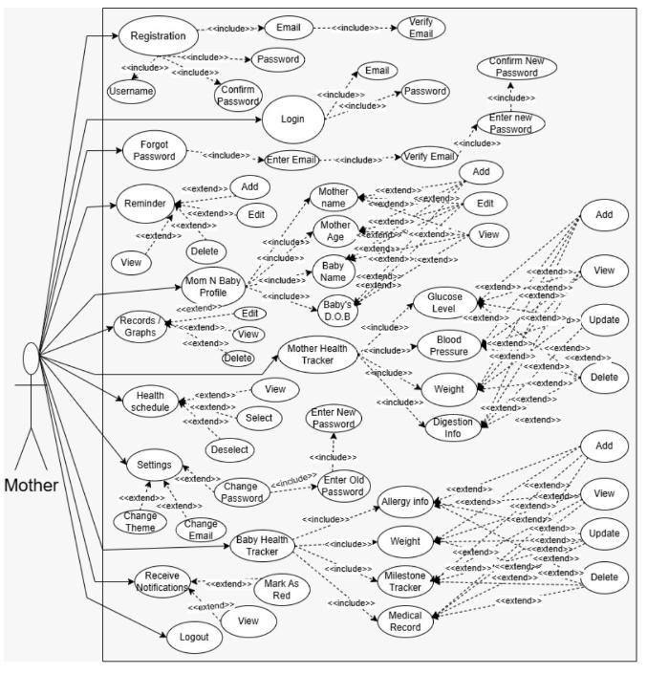
Figure 1: Use Case Diagram

3.7 Storyboards:
Storyboard 1
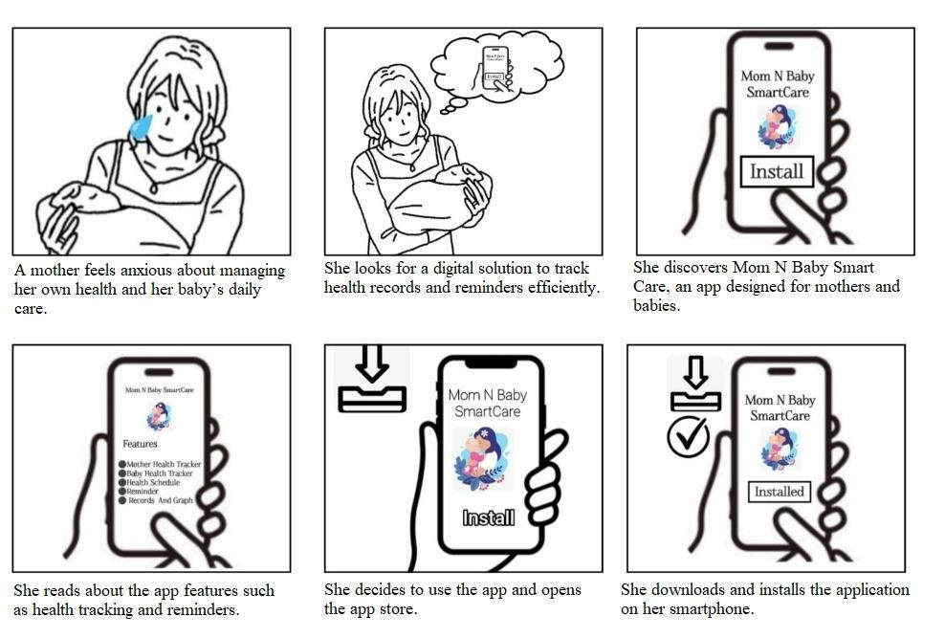
Figure 2: App Awareness & Installation
Storyboard 2
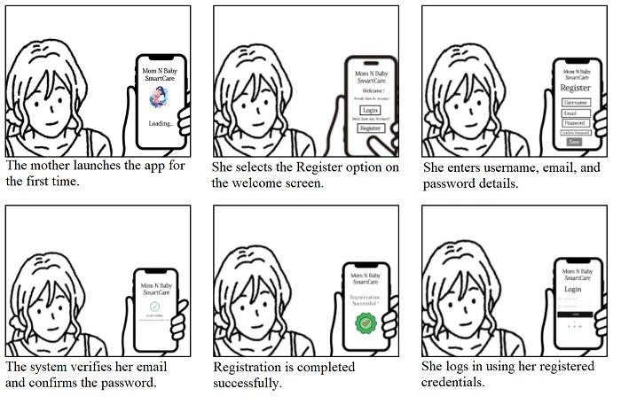
Figure 3: Registration & Login

3
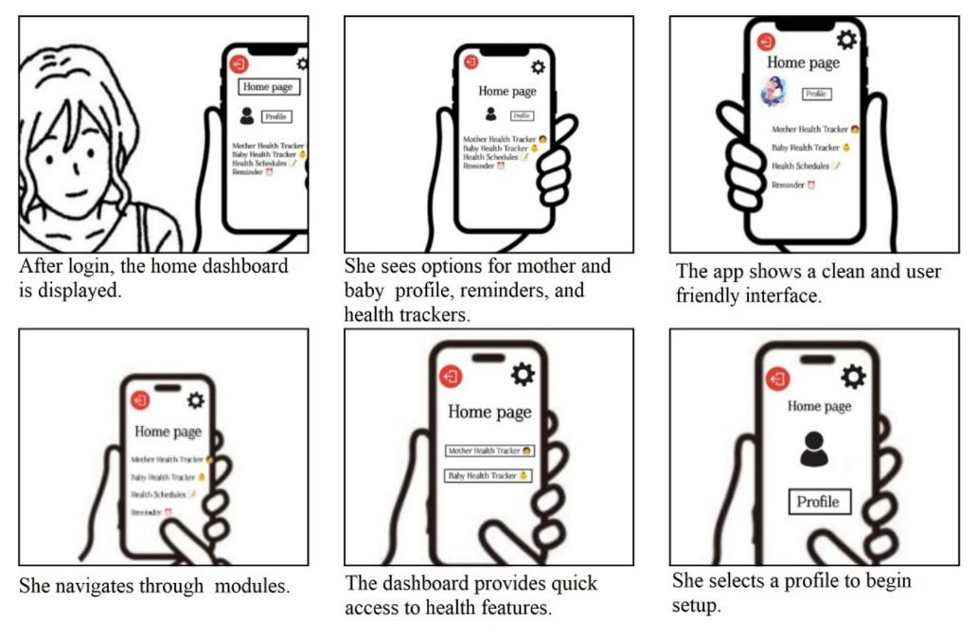
Figure 4: Home Dashboard Access
Storyboard 4
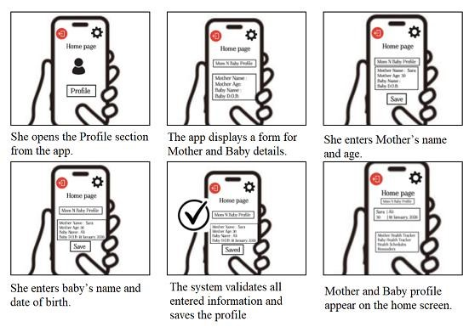
Figure 5: Mom N Baby Profile Creation
5
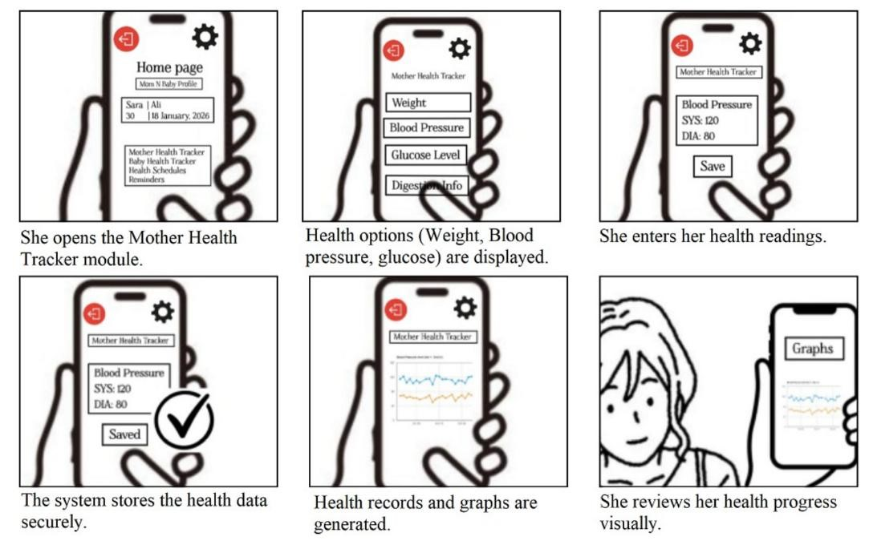
Figure 6: Mother Health Tracking
Storyboard 6
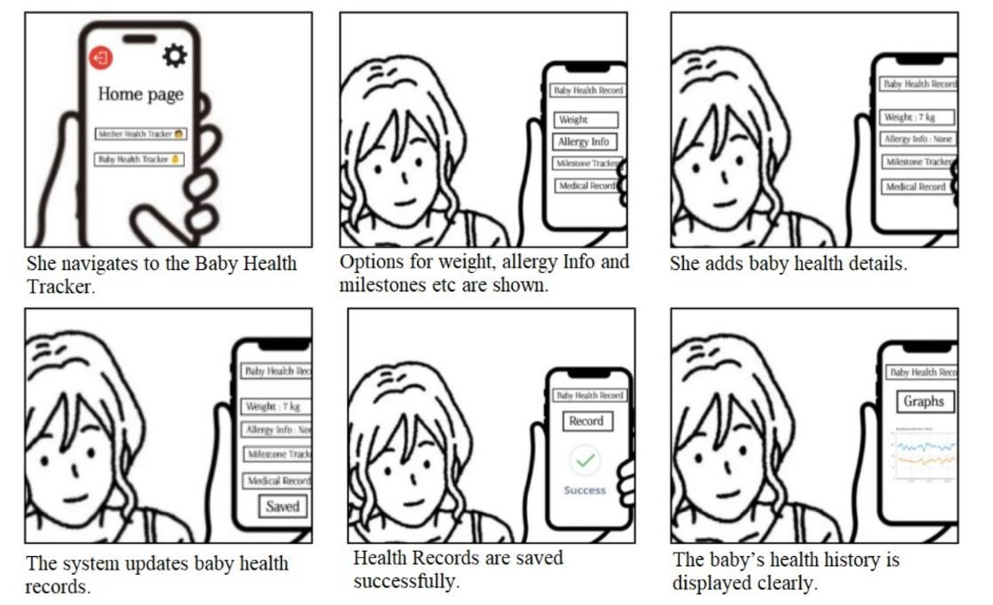
Figure 7: Baby Health Tracking
7
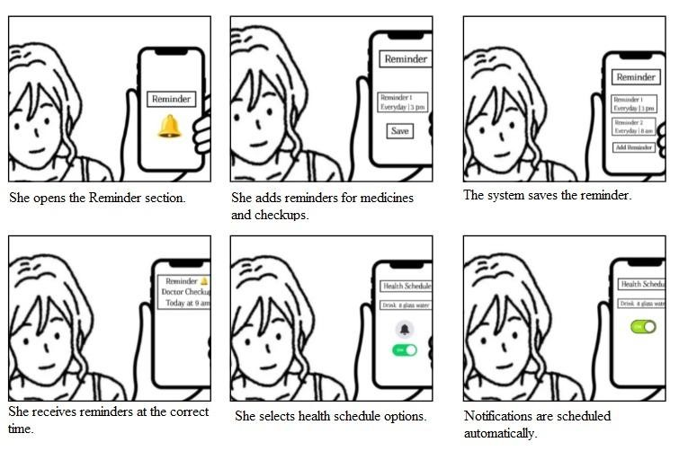
Figure 8: Reminders & Health Schedule
Storyboard 8
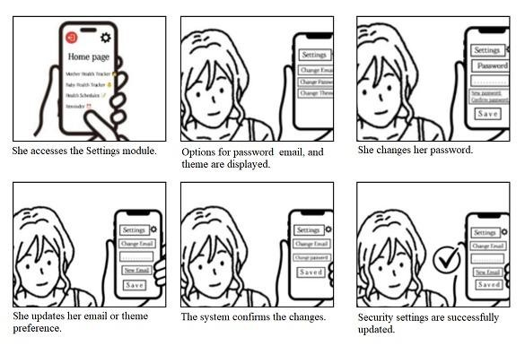
Figure 9: Settings Management
9
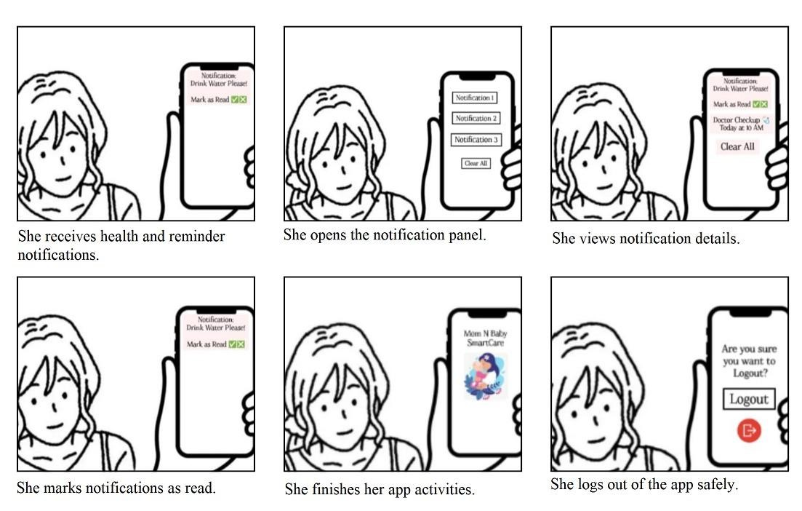
Figure 10: Notifications & Logout

3.8 Summary:
Mom N Baby SmartCare SRS describes the requirements of a mobile application that supports mothers in managing their own health and their babies’ health in a single platform. It explains system features such as user registration, secure login, profile management, mother and baby health tracking, reminders, notifications, records with graphs, and settings management. The document also defines non-functional requirements, including usability, performance, reliability, security, and availability, to ensure smooth and safe operation of the application. Use cases and storyboards are included to clearly show user interactions and system behavior, providing a strong foundation for developing a simple, organized, and dependable health management application for mothers and babies.

References:
Book
Pressman, R. S. Software Engineering: A Practitioner’s Approach. New York:
McGraw-Hill Education, 2014, pp. 45–110.
Sommerville, I. Software Engineering. Boston: Pearson Education, 2016, pp. 120– 190.
Article in a Journal
Bevan, N. “Usability issues in mobile application design.” International Journal of Human–Computer Studies, vol. 69, pp. 1–15, Jan. 2011.
Conference Proceedings Articles (published)
Nielsen, M., and Molich, K. “User interface design for mobile health applications.”
In Proceedings of the International Conference on Human-Computer Interaction, 2013, pp. 45–52.
World Wide Web
Android Developers. “Android Application Fundamentals.” Internet:
https://developer.android.com/guide/components/fundamentals, updated 2024 IEEE Computer Society. “IEEE Std 830-1998: Recommended Practice for Software
Requirements Specifications.” Internet: https://standards.ieee.org/standard/830-
1998.html, updated 2018
Canva, “UI Design Template for Mobile Application.”Internet:
https://www.canva.com/design/DAGgL1fHAo/tg06PH21661APXetthjm0Q/edit InShot – Video Editor & Maker. Available: https://inshot.com

